PUT YOUR PROJECT TITLE HERE

BEng PROJECT PROPOSAL AND PLANNING REPORT

Author: Zhiguo Tao
Student ID: 20514075
Course: Mechanical Engineering
Date of report: 6th November 2025
Supervisor: Xin Dong

In submitting this report I confirm that my project supports the engineering orientation of my Aerospace/Mechanical/Manufacturing engineering degree
In submitting this report I confirm that the following AI tools were used in its preparation, for the purpose of (delete all not applicable)
- Improving grammar, spelling, and clarity across my writing.
- Drafting or refining report content (but only with substantial editing and personal input).
- Helping me explore possible research questions, structures, or approaches.
- Supporting literature reviews (e.g., suggesting themes, identifying gaps) but I also confirm I have critically assessed all reference sources myself.
- Checking whether my work meets marking criteria
- Something else (please say what)
OR
In submitting this report I confirm that I have not used AI tools at all in generating the content or the report itself.

Contents
1. BACKGROUND AND CONTEXT FOR THE WORK 3
2. AIM AND OBJECTIVES 4
3. PLANNING 5
4. PROJECT RISK ASSESSMENT 6
5. REFERENCES 7
APPENDIX 1 9

The table of contents generates automatically. Click the mouse over “Contents” and select “update table” to update the contents page after you have made changes to the report.

BACKGROUND AND CONTEXT FOR THE WORK

In recent years, due to multiple effects, including climate change, pests and diseases, food security has become a major global challenge. According to the predictions by the FAO, global food demand is expected to increase by 60% from 2010 to 2050, while the arable land area is estimated to grow by less than 5%[1]. Meanwhile, crops face many threats to their living environment in agricultural production. For example, rice is the world's most widely planted crop, grown in over 100 countries, rice is easily influenced by biological stresses (such as rice blast caused by Magnaporthe oryzae and brown planthoppers Nilaparvata lugens) and non-biological stresses (including drought, high temperatures, and salt stress)[8]. These stresses are often difficult to detect and occur commonly in the growth cycle. In this background, agricultural development requires a transition toward digitalization. Sensor technology, as the basis of agricultural digitalization, is developing rapidly. The global agricultural sensor market is predicted to reach approximately $6 billion by 2030, with an annual growth rate exceeding 13%[7].

Traditional sensors are usually rigid structures, they are often installed in air or soil to monitor environmental parameters. However, monitoring environmental parameters alone cannot fully reflect the true physiological state of plants[9]. Research indicates that, when plants are subjected to stresses such as drought, high temperatures, or diseases, the earliest changes typically occur internally, like leaf temperature, chlorophyll content, and stomatal conductance [2],so may misjudge the current situation if only consider the environmental stress, combining these with internal plant parameters could improve the accuracy of judging physiological status and yield changes [3]. However, traditional sensors attached to leaves may cause physical damage. Alternative monitoring methods like computer vision (CV) and spectroscopy [4] are susceptible to ambient light variations, require sophisticated equipment and are costly [5].

Therefore, flexible wearable plant sensors have become a research hotspot in recent years. Such sensor patches can closely fit leaves without causing damage,as shown in figure 1.Research indicates that, using flexible PDMS as the substrate and Galinstan for liquid metal circuits, in stress-strain tests, after exceeding 110% strain, the patches can hold without fracture. In fatigue tests, after 5000 bending cycles, the patches can remain the stable electrical conductivity, showing excellent toughness[6]. Building upon these established designs and theories, this project seeks to improve and manufacture a low-cost, flexible, wearable sensor to contribute to solving global food challenges.
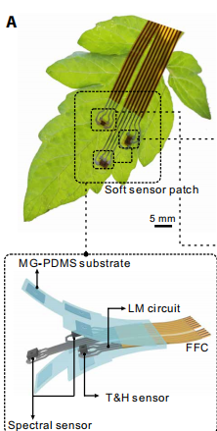
Figure 1.

AIM AND OBJECTIVES

Aim
The aim of this project is to design and manufacture a flexible soft sensor patch that can adhere to plant leaf surfaces. This patch enables real-time monitoring of environmental and physiological parameters—such as temperature, humidity, and chlorophyll content—to evaluate plant stress conditions.
Objects
- Conduct a literature review to summarize the latest research progress in soft sensor technology and flexible electronic materials, determine the general design direction
- Design and manufacture flexible sensor patches using polydimethylsiloxane (PDMS) as the flexible substrate, 3D-print PET moulds, spray-print flexible circuits, and connect sensors.
- Connect the flexible patch assembly to the Arduino, and develop the programs to achieve real-time monitoring, then record the data of temperature, humidity, and chlorophyll
- Conduct experiments by adhering sensors to leaves, record data, analyze findings, and prepare reports, and evaluate sensor adhesion stability, data accuracy, and long-term stability

.

PLANNING
WP1: Preliminary Planning and Preparation
WP1 covers the project's preparatory phase and overall planning. This includes initiating a literature review, defining research objectives and goals, developing a preliminary Gantt chart, and completing the risk assessment.
Milestone: Proposal and Planning Report.

WP2: Patch Design and Fabrication
WP2 focuses on the research, development, and manufacturing of flexible sensor patches. This includes preparing PDMS substrates; designing liquid metal circuits; manufacturing PET moulds; and completing spraying and encapsulation processes. The objective of this phase is to obtain functional sensor patch prototypes that can be adhered to plant leaf surfaces.
Milestone: Prototype samples of flexible sensors.

WP3: System Integration and Testing
WP3 focuses on sensor system integration and signal testing. This includes connecting sensor patches to the Arduino, debugging temperature/humidity and spectral sensor modules, and writing programs for preliminary testing.
Milestone: Integrated sensor system and preliminary data output results.

WP4: Experiment conduction and Evaluation
WP4 focuses on evaluating the performance of flexible sensors under experimental conditions and analyzing their data. This includes testing the adhesion stability of sensors in both laboratory and natural environments, followed by the sorting and analysis of collected data. This phase will provide the experimental basis for the project's final evaluation and reporting.
Milestone: Experimental data report and analysis results.

WP5: Deliverables and Report Writing
WP5 focuses on summarizing project outcomes and drafting the formal report, including writing Dissertation, final data compilation, and presentation material preparation. This part will progressively complete the project summary and deliverables.
Milestone: Dissertation and Presentation Slides.
Throughout the project, multiple milestones and deliverables have been planned. These include not only project deliverables (such as proposals, planning reports, and final dissertations) but also technical milestones.
The complete Gantt chart is detailed in Appendix 1.
See appendix 1 for the full Gantt chart.

PROJECT RISK ASSESSMENT
During the project risk assessment process, several potential risks were identified.
First risk is some mistake might happen during the patch fabrication process. If the raw material ratios are inaccurate during the preparation of polydimethylsiloxane (PDMS), it may cause uneven coating and reduced conductivity. The second risk is the unavailability or damage of experimental equipment (such as laser cutters), this may delay mould manufacturing and affect overall project progress. The third risk is adhesive failure of the patches, as this may cause the separate between patches and the blades.
Software-related risks: Errors in Arduino programming or data acquisition may result in incorrect or missing data.
Environmental risks: Environmental disturbances (such as temperature or humidity fluctuations) may affect the accuracy and precision of sensor data readings.
Overall, these identified risks have been quantitatively assessed in the Probability and Impact Diagram (PID). The most severe risks are manufacturing processes and equipment availability, both rated at a medium-to-high severity level. Mitigation strategies have been established to ensure the successful conduct of the experiment. (See Appendix 1 for the complete risk assessment table.)

REFERENCES
[1] Food and Agriculture Organization (FAO), The Future of Food and Agriculture: Trends and Challenges. Rome, Italy: Food and Agriculture Organization of the United Nations, 2017. [Online]. Available: https://www.fao.org/3/i6583e/i6583e.pdf
[2] C. Zhao et al., “Temperature increase reduces global yields of major crops in four independent estimates,” Proc. Natl. Acad. Sci. U.S.A., vol. 114, no. 35, pp. 9326–9331, 2017. [Online]. Available: https://doi.org/10.1073/pnas.1701762114
[3] Z. Jiang et al., “Physiological, molecular, and environmental insights into plant responses to drought stress,” Plant Genome, vol. 17, no. 1, p. e20461, 2024. [Online]. Available: https://acsess.onlinelibrary.wiley.com/doi/10.1002/tpg2.20461
[4] A. K. Mahlein, “Plant disease detection by imaging sensors – parallels and specific demands for precision agriculture and plant phenotyping,” Plant Dis., vol. 100, no. 2, pp. 241–251, 2016. [Online]. Available: https://doi.org/10.1094/PDIS-03-15-0340-FE
[5] C. Xie, C. Yang, and Y. He, “Hyperspectral imaging for plant disease detection and classification with deep learning models,” Infrared Phys. Technol., vol. 104, p. 103–119, 2020. [Online]. Available: https://doi.org/10.1016/j.infrared.2019.103–119
[6] Q. Jiang et al., “A machine-learning–powered spectral-dominant multimodal soft wearable system for long-term and early-stage diagnosis of plant stresses,” Sci. Adv., vol. 11, no. 2, p. eadl2003, 2025. [Online]. Available: https://www.science.org/doi/10.1126/sciadv.adl2003
[7] Markets and Markets, Agricultural Sensors Market by Type, Application, and Region – Global Forecast to 2030. Pune, India: MarketsandMarkets Research Pvt. Ltd., 2023. [Online]. Available: https://www.marketsandmarkets.com/Market-Reports/agriculture-sensor-market-1119.html
[8] S. Savary, L. Willocquet, S. J. Pethybridge, P. Esker, N. McRoberts, and A. Nelson, “The global burden of pathogens and pests on major food crops,” Nat. Ecol. Evol., vol. 3, no. 3, pp. 430–439, 2019. [Online]. Available: https://doi.org/10.1038/s41559-018-0793-y
[9] M. Fujita et al., “Crosstalk between abiotic and biotic stress responses: A current view from the points of convergence in the stress signaling networks,” Curr. Opin. Plant Biol., vol. 9, no. 4, pp. 436–442, 2006. [Online]. Available: https://doi.org/10.1016/j.pbi.2006.05.014

APPENDIX 1
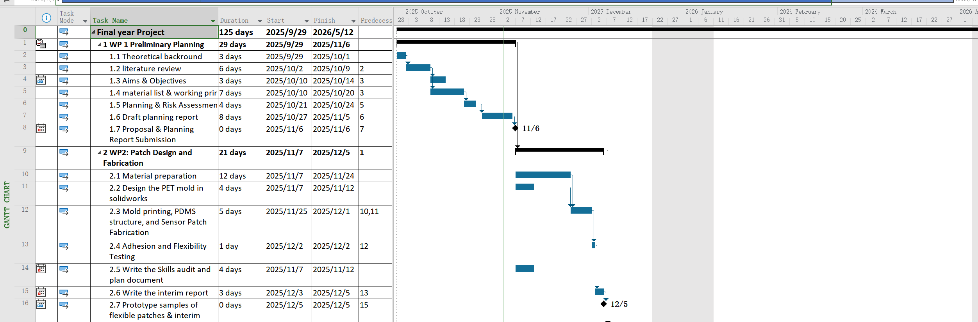Figure 2.1
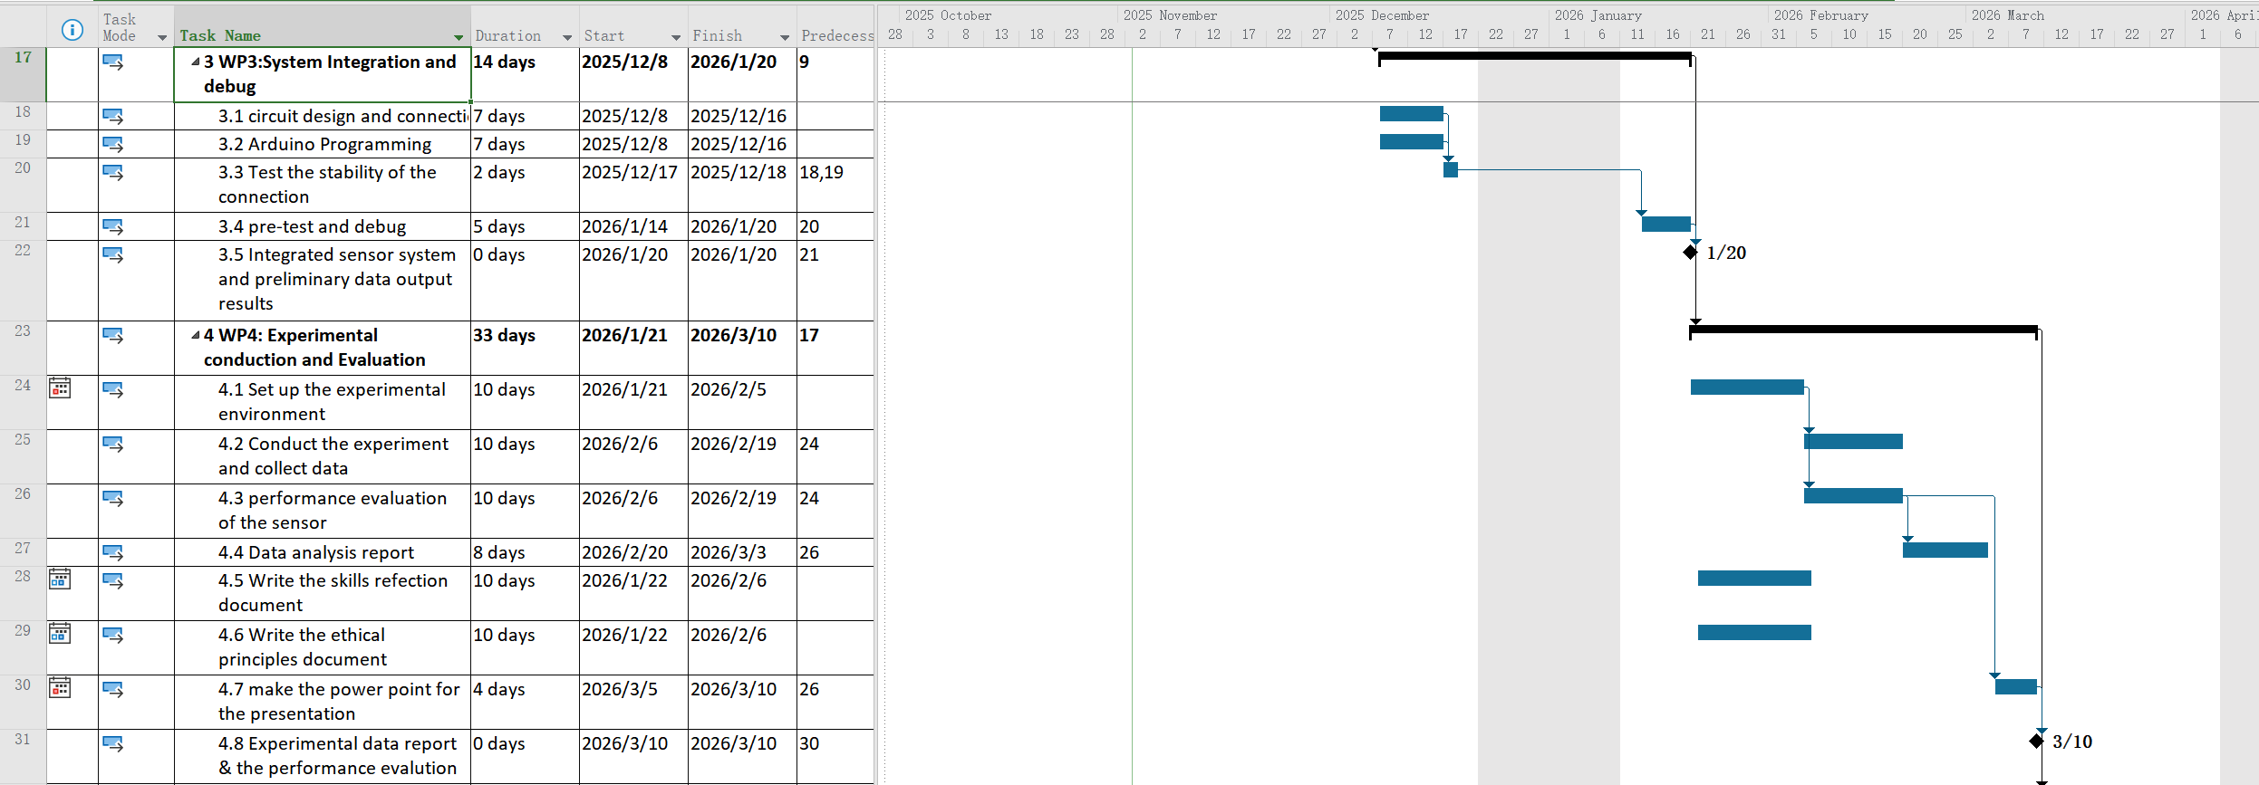Figure 2.2
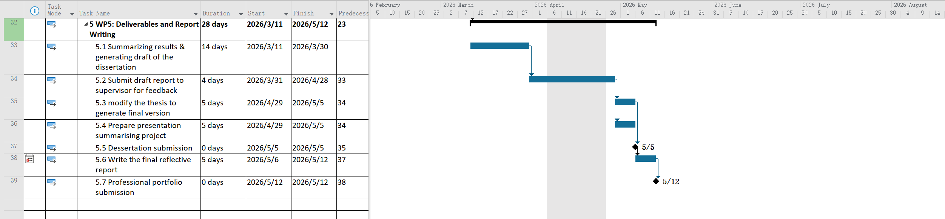Figure 2.3
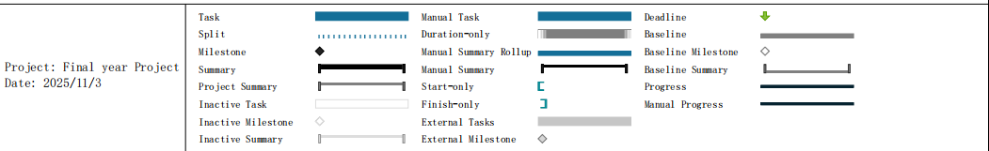Figure 2.4

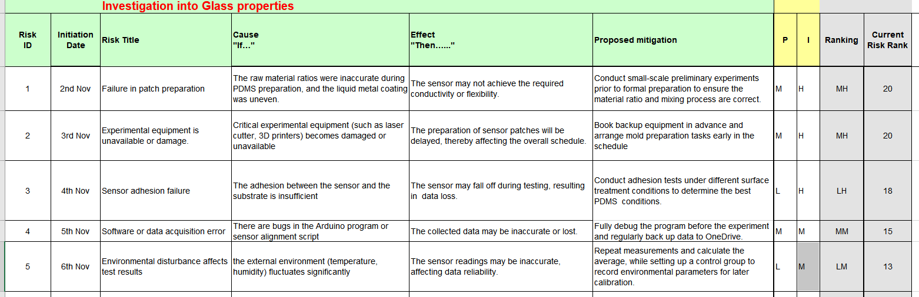Figure 3.1
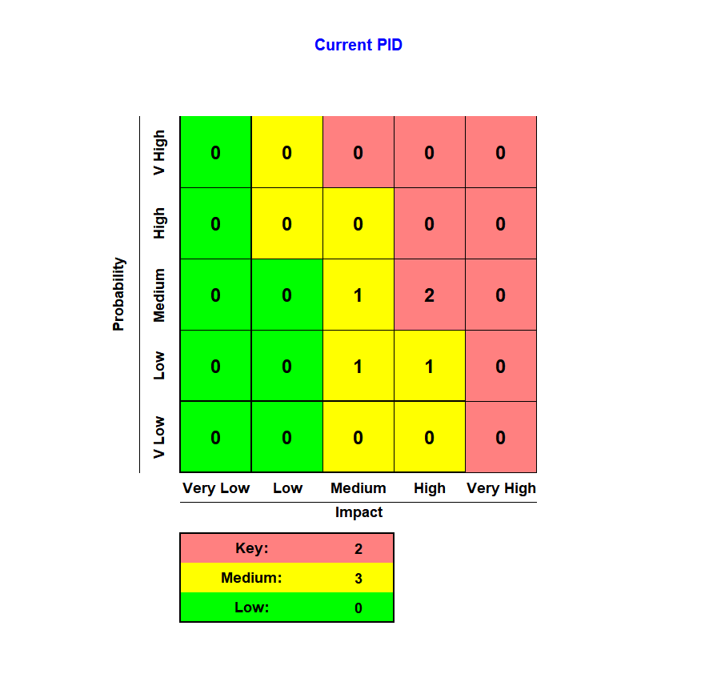
Figure 3.2

